How To Setup Application, follow step as given below

**Step 1 :** Download Xaamp from google.

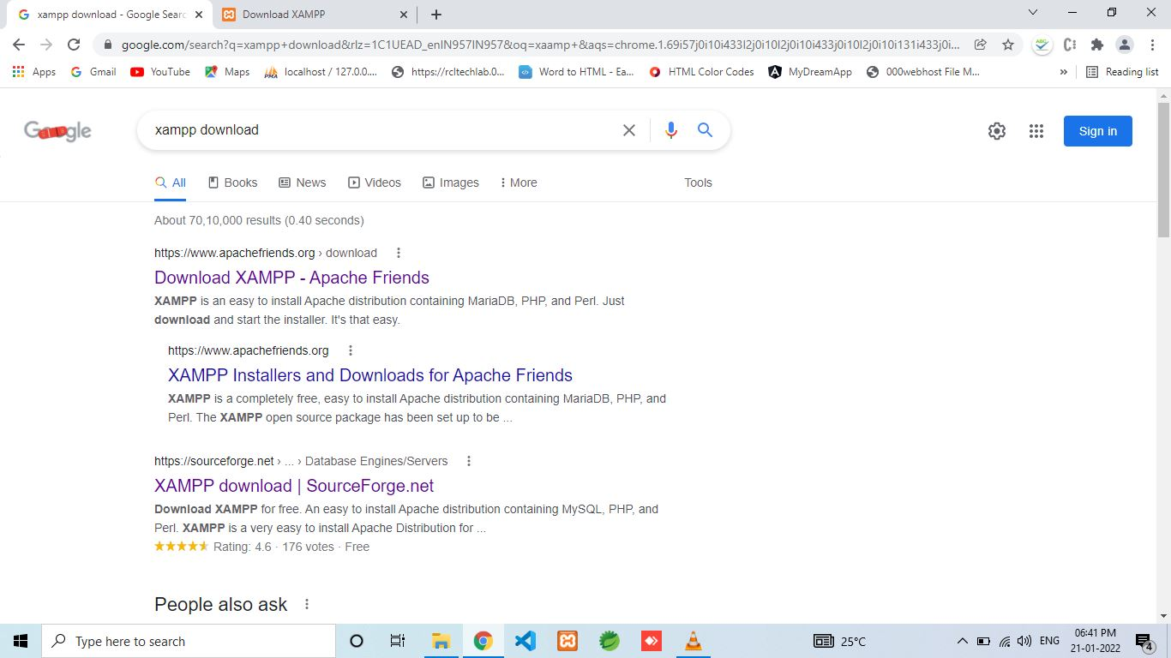

Go to First Link, you will directed to download page.

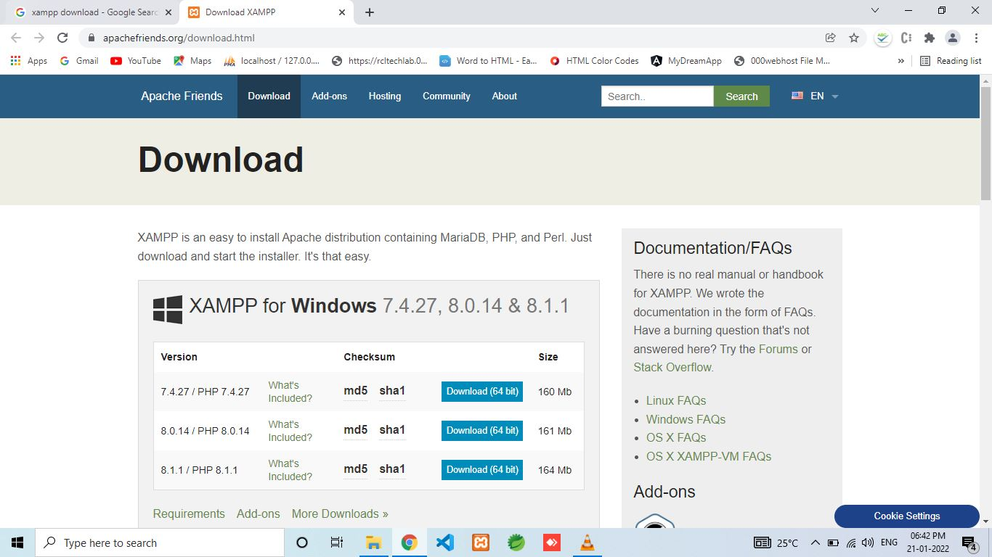

Take a download as your Operating System Choice.

**Step 2 :** Install Xaamp on your machine

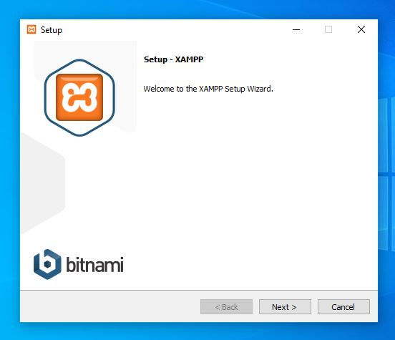

Click Next

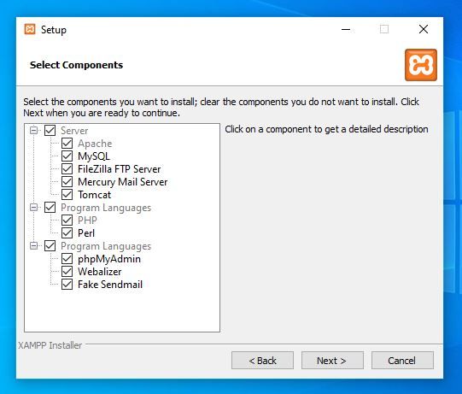

Keep all ticks as it is.

**Step 3 :** Go to Local disk C, Open Xaamp folder as shown below.

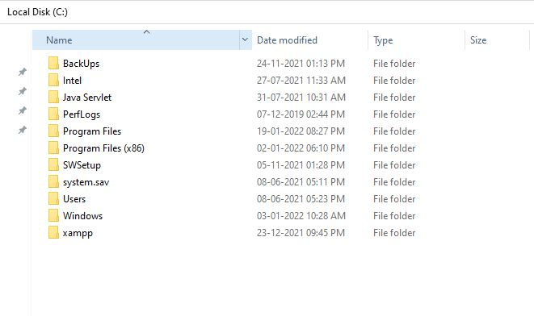

Open xaamp and go to htdocs folder, paste your project file inside this folder.

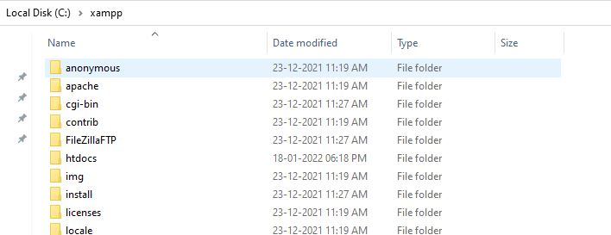

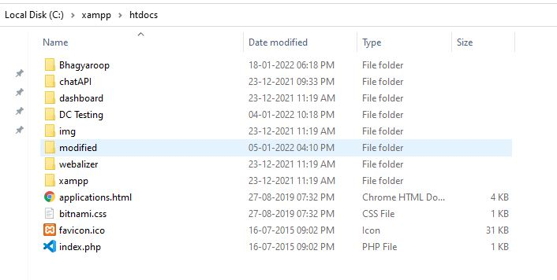

**Step 4:** Update Database.

Search xaamp on windows search, Run xaamp server.

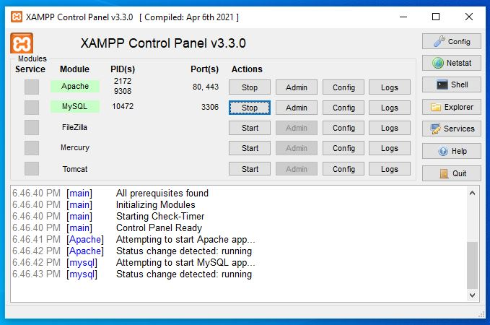

Open Web browser go to following link

<http://localhost/phpmyadmin/>

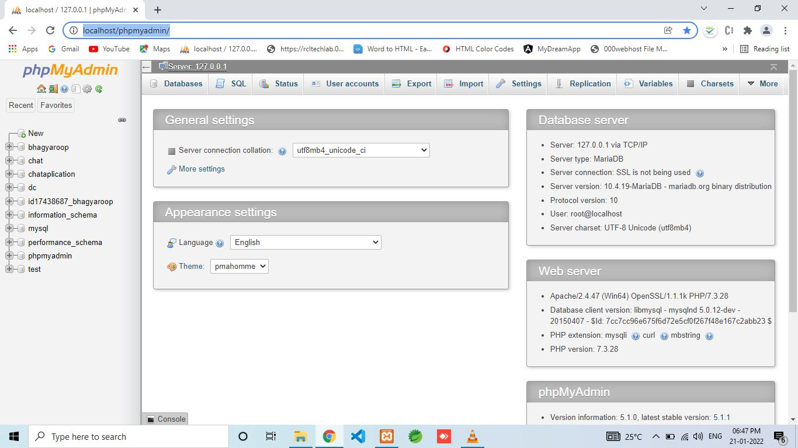

Go to Import Tab.

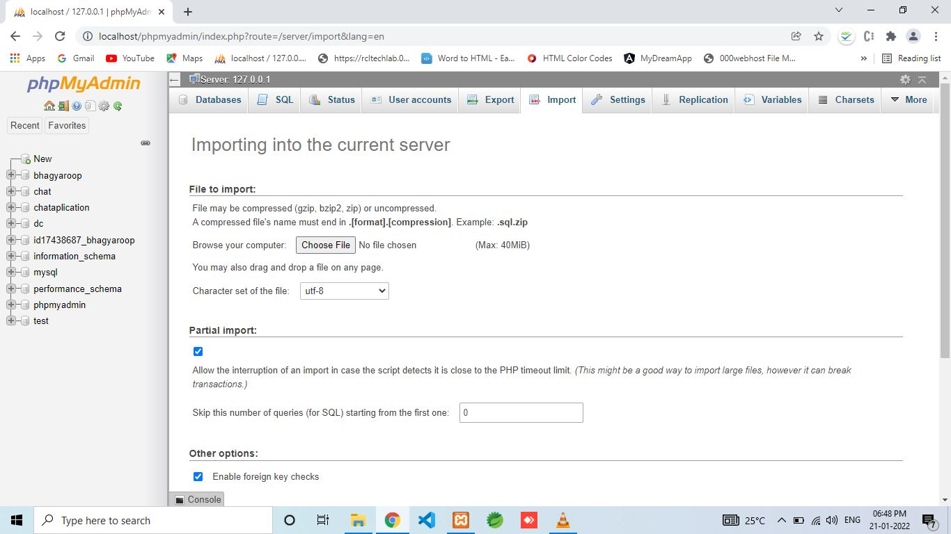

Choose Your Database file upload through “Choose file” button.

All Done !

Run following link on your web browser.

<http://localhost/Bhagyaroop/>

